Canaliza

Final Report

Rui Monteiro 202300265

Daniel Pais 202200286

Dinis Xavier 202300148



Table of Contents

Project Identification 2
1. Title 2
2. Logo 2
3. Abstract 2
Lean Canvas 3
4. Existing Alternatives and Market Benchmarking 4
Project Charter 5
5. Technical Framework 5
6. Technical Assumptions 5
7. Intended Technology Readiness Level (TRL) 6
8. Purpose / Justification 7
9. Product Overview 8
10. Objectives 9
11. Preliminary Scope Statement 10
12. Stakeholder Analysis 10
13. Key Performance Indicators (KPIs) 11
14. Revenue Model 16
15. Project Timeline (21 Weeks) 16
16. Project Governance 17
Work Breakdown Structure 19
17. WBS 19
18. Gantt Chart 20
19. Description of Project deliverables 20
20. WBS Dictionary 21
Budget & CashFlow 25
21. Project Cost Baseline 25
22. Resource Cost Calculation 26
23. Cash-Flow 26
24. Cost Breakdown Structure (CBS) 28
25. Project Resource Management 29
26. Project Risk Management 30
Annex A: Prompt Engineering 38
Annex B: Costs and Budget 38
Annex C: Resource Cost 38

Project Identification

Title
Canaliza - the name comes from the Portuguese word canalizador (meaning plumber), but it also sounds like a command: canaliza!, “make it flow,” “fix it,” “get it done.”
It’s simple, memorable, and full of action, perfectly capturing the spirit of a fast, reliable plumbing service at your fingertips.

Logo
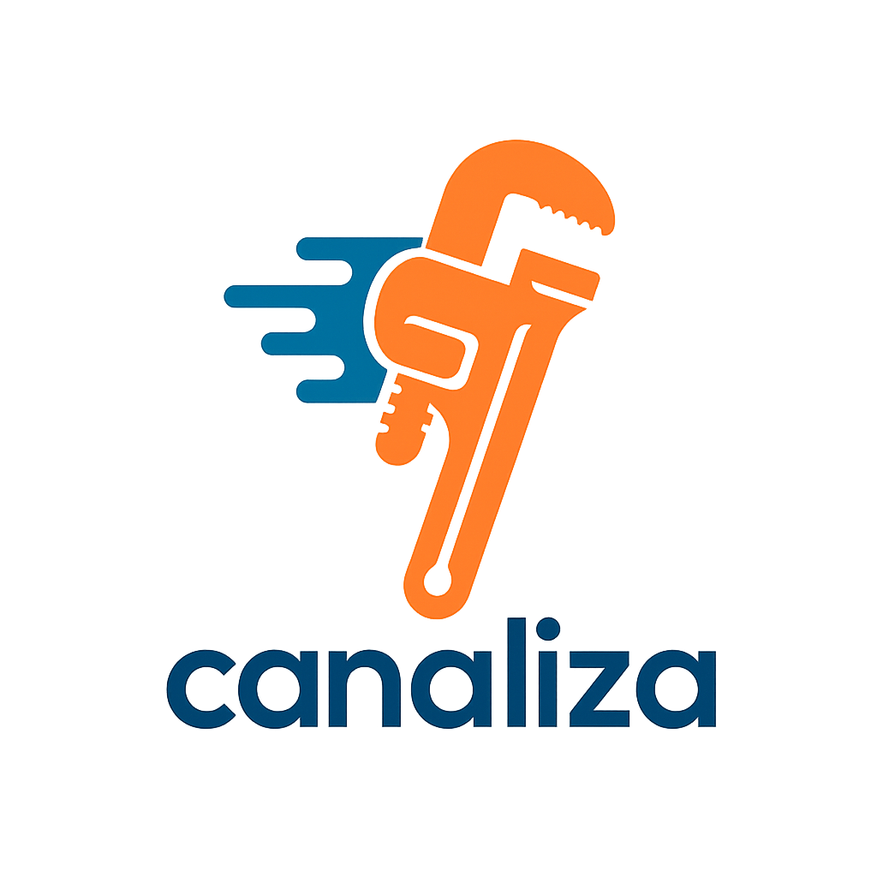
Fig.1 - Canaliza logo

Fig.1 shows a pipe wrench with speed lines, representing plumbing work and quick service.
The blue color stands for water, speed, and professionalism, while the orange color adds expertise, action, and friendliness.

Together, they create a clean and modern look that shows Canaliza is fast, reliable, and easy to use.

Abstract
Canaliza was created to address the growing need for fast, reliable, and accessible plumbing services. Users often face the same issue: they don’t know who to call.

The platform connects customers with verified plumbers, allowing them to describe their problem, receive clear quotes, and choose professionals based on trusted reviews. For professionals, Canaliza provides visibility, direct communication, and a steady flow of clients.

The goal is to reduce response times, increase trust, and make plumbing services simple, digital, and secure, one click away.

Sector
Plumbing services cover the installation, repair, and maintenance of water, gas, and waste systems, ensuring safe water flow and proper sanitation in homes and buildings.

Lean Canvas
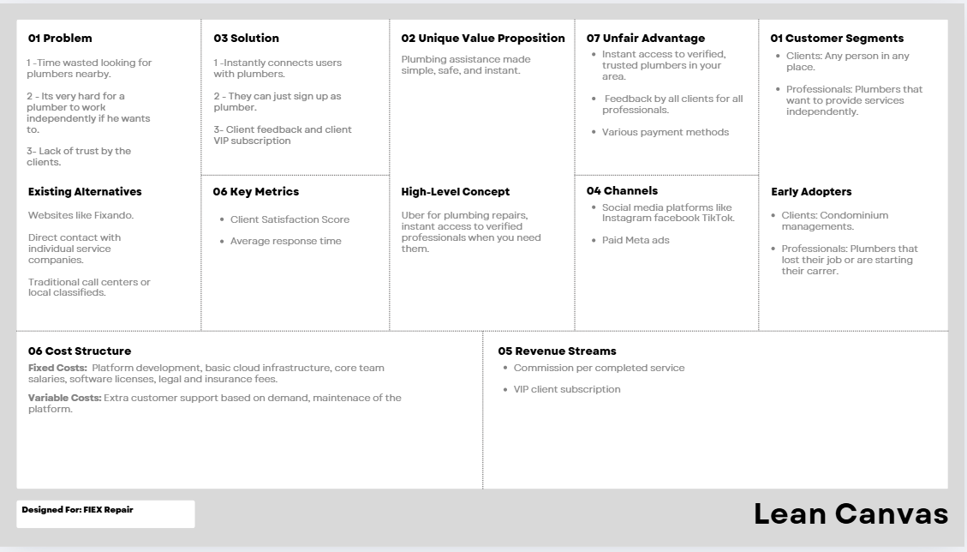
Fig.2 - Lean Canvas

Existing Alternatives and Market Benchmarking
To better position the proposed platform, a market benchmarking analysis was conducted to identify and evaluate existing alternatives currently used by customers to find technical assistance services. This analysis highlights their main characteristics, strengths, and limitations, helping to justify the need for the proposed solution.

Online Service Marketplaces (e.g., Fixando)
Platforms such as Fixando provide a broad marketplace where customers can request services from multiple professionals across different categories. While these platforms offer convenience and visibility, they are often too generic, making it difficult to ensure specialization in technical assistance services. Additionally, response times and service quality can vary significantly, and competition among professionals may reduce trust and consistency.

Direct Contact with Individual Service Companies
Many customers rely on contacting service companies or independent professionals directly, usually through phone calls or websites. Although this approach may offer familiarity and perceived reliability, it is often time-consuming, lacks transparency in pricing and availability, and provides limited options for comparison or quick replacement if a professional is unavailable.

Traditional Call Centers or Local Classifieds
Local classifieds, newspapers, and call centers remain a common alternative, especially for less digitally engaged users. However, these methods are typically inefficient and outdated, offering little to no validation of service quality, slow response times, and minimal accountability or customer feedback mechanisms.

Conclusion of Benchmarking
The analysis shows that existing alternatives either lack specialization, transparency, or efficiency. These gaps create an opportunity for a dedicated technical assistance platform that combines speed, trust, quality assurance, and professional independence in a single digital solution.

Project Charter

Technical Framework
The project follows the Agile SCRUM methodology, enabling iterative development, continuous feedback, and incremental delivery of functionality in alignment with the project’s governance model.
The system architecture is based on the Model–View–Controller (MVC) pattern, promoting separation of concerns, maintainability, and scalability, and supporting the implementation of rule-based business logic in the initial system version.
The development environment is based on Microsoft Windows, ensuring compatibility with the selected development tools and runtime environment.
The technology stack is centered on the .NET Framework for backend development, complemented by a modern web frontend framework. This stack was selected for its maturity, performance, security capabilities, and ease of integration with cloud infrastructure and third-party services via standard APIs.
Project management activities are supported by Jira for sprint planning and progress tracking. GitHub is used for version control and collaborative development, while Google Docs is used for centralized and collaborative project documentation.

Technical Assumptions
The project management plan is based on the following technical assumptions:
- The selected technology stack (.NET for backend and a modern web frontend framework) will be sufficient to support the functional and performance requirements of the platform.
- Cloud infrastructure services will be available and scalable to handle expected user load during initial deployment.
- Third-party services (e.g., authentication, payment gateways, notification services) will be reliable and easily integrable via standard APIs.
- The matching algorithm between customers and professionals can be implemented using rule-based logic without the need for advanced machine learning techniques in the initial version.
- Development and testing environments will be available throughout the project lifecycle without major disruptions.
- Team members possess the necessary technical skills to implement the proposed architecture within the planned schedule.
- Security best practices and GDPR compliance can be achieved using standard frameworks and libraries.

Intended Technology Readiness Level (TRL)

Chosen TRL: TRL 6 – Technology demonstrated in a relevant environment
The intended Technology Readiness Level (TRL) for this project is TRL 6, corresponding to a system that is planned to be implemented and demonstrated in a relevant, near-operational environment, supported by measurable technical and data-driven validation criteria.
According to the TRL framework, level 6 requires a working system prototype capable of demonstrating end-to-end functionality under conditions that closely resemble real-world operation. This project is designed with the explicit objective of reaching this level of maturity by the end of its development cycle.
The proposed platform will integrate mature technologies, including a .NET-based backend, RESTful APIs, a relational database, and cloud-based infrastructure. While these technologies are individually well-established, the project’s intended contribution lies in their integrated application, combined with data collection and analytics mechanisms that will support system validation and performance assessment.
To reach TRL 6, the system is intended to:
- Implement functional core features, such as user registration, service request management, professional matching, and review submission, with all interactions generating structured operational data.
- Demonstrate end-to-end data flow between frontend, backend, and database layers, enabling traceability and analytical inspection of system behavior.
- Operate in a controlled but realistic cloud-based environment, such as a staging or pre-production setup that mirrors production architecture.
- Support planned performance and reliability evaluation, using quantitative metrics including API response times, throughput, error rates, and concurrent request handling.
- Enable basic data analytics capabilities, allowing aggregation and analysis of service request volumes, matching efficiency, cancellation rates and resolution times.
- Incorporate security, privacy, and data governance mechanisms, including authentication, role-based access control, and GDPR-aware data handling, as prerequisites for reliable data analysis.
The project does not intend to reach TRL 7 within its current scope, as it will not involve sustained deployment in a fully operational commercial environment nor long-term validation using large-scale, heterogeneous user populations.

Measurable Indicators Supporting TRL 6
The achievement of TRL 6 is supported by the following measurable indicators:
- Successful execution of integration and acceptance tests across frontend, backend, and database layers.
- Demonstrated handling of concurrent service requests within predefined performance limits (e.g., acceptable response times under simulated load).
- Verified persistence, retrieval, and consistency of user and service data in a cloud-hosted relational database.
- Availability of documented system architecture, API specifications, and deployment configurations.
- Completion of User Acceptance Testing (UAT) using realistic usage scenarios that simulate real-world workflows.

Purpose / Justification
The main goal of the Canaliza app is to simplify access to reliable plumbing assistance by creating a seamless digital bridge between customers and qualified professionals.

This project aims to modernize and optimize the plumbing service market, ensuring convenience, reliability, and fair opportunities for both clients and service providers.

Product Overview

Problems we are solving
Problem 1
Time wasted looking for professionals nearby - When users face an unexpected plumbing issue, they often spend hours searching for a reliable professional near them.

They have to browse multiple websites, look for companies that provide that service, read reviews, make calls, and wait for replies that may never come. This process is not only time-consuming, but also frustrating and uncertain, especially when the problem requires an urgent fix.

Problem 2
It's very hard for a professional to work independently - Many skilled plumbers struggle to work independently because they lack access to clients, marketing tools, and reliable payment systems.

Without a stable flow of requests or a trusted digital presence, these professionals often rely on word of mouth or third-party agencies that take high commissions. As a result, their income becomes inconsistent, their exposure limited, and their ability to grow a personal business severely restricted.
Problem 3
Lack of trust by the clients - One of the biggest challenges in the plumbing market is trust. Many clients hesitate to hire independent professionals because they fear poor service quality, hidden costs, or even scams.

Without transparency or verified information, which usually are not easy to find if the service is being requested bodily, users often feel insecure when allowing someone into their home or business.

Our solutions
Solution 1
Our app eliminates wasted time by providing a centralized digital platform that instantly connects users with verified and available plumbers nearby (through intelligent matching algorithms and automated notifications, the app ensures that only relevant and active professionals respond).

With just a few clicks, users can describe their problem, receive real-time quotes, and select the right professional based on ratings, certifications, and availability.

Solution 2
Our app gives independent plumbers the freedom and structure they need to build and manage their own business.

Through the platform, technicians can create verified profiles(as professionals), receive job requests directly, and control their pricing and schedule.

Solution 3
Our app builds trust and transparency into every interaction. Each plumber is verified through documentation and client feedback, and every completed job generates a review and rating that becomes visible to future users.

To further strengthen reliability, we introduce the VIP Client option — a premium feature that prioritizes top-rated and most reliable plumbers for those clients who value guaranteed quality and faster response times.

With these clients can check if a professional has good reviews or not based on the experiences of other clients.

Objectives
- Develop an intuitive and user-friendly web platform that enables customers to quickly request plumbing services with minimal effort and maximum efficiency.

- Build a sustainable digital ecosystem that connects and supports both sides of the market — clients seeking trustworthy assistance and plumbers seeking consistent work opportunities.

- Guarantee transparency, reliability, and speed in all service interactions through verified profiles, real-time communication, and clear pricing.

- Reduce the average time required to find a qualified plumber by at least 50%, compared to traditional search methods.

- Empower new professionals to start their careers faster by providing them with digital visibility, client access, and a simplified onboarding process within the platform.

Preliminary Scope Statement

In Scope
- User registration and authentication (clients and professionals).

- Service request and dynamic pricing system.

- Real-time matching algorithm for nearby professionals.

- Rating, review, and feedback functionality.

Out of Scope
- The project does not include the direct hiring, contracting, or management of service providers.

- The platform will initially focus exclusively on plumbing services, excluding other technical or non-technical categories.

Stakeholder Analysis
Stakeholder Group | Role and Relevance | Motivation / Early Adopters
Clients (End Users) | Request and pay for plumbing services through the platform. They represent the primary source of demand and revenue. | Condominium managers, real-estate owners, and individuals with frequent maintenance needs or small plumbing problems.
Plumbers (Service Providers) | Offer plumbing services via the platform and fulfill service requests. They are essential for service availability and platform credibility. | Recently unemployed professionals, independent plumbers, and early-career technicians seeking digital exposure and client acquisition.
Project Team | Responsible for system design, development, deployment, and maintenance. Ensures quality, security, and performance of the platform. | Academic and professional interest in delivering a functional, high-quality solution within project constraints.

Key Performance Indicators (KPIs)

Measure  (x) | Green Target | Yellow  Target | Red Target | Source | Category | Measurement Frequency
Client Satisfaction Score (1 to 5) | ≥ 4.0 | 2.5 – 3.9 | ≤ 2.5 | Review database | Lagging / Benefit | Monthly
Average response time (min) | ≤ 1.5 min | 1.5 – 3.0 min | > 3.0 min | Request logs | Leading / On-target | Real-time
Order Completion Rate | >= 85% | 70–84% | < 70% | Orders DB | Lagging / Benefit | Weekly
Cancellation Rate | <= 8% | 9–14% | > 14% | Orders DB | Lagging / Cost | Monthly
Total Service Lead Time | <= 48h | 49–72h | > 72h | Orders DB | Lagging / Cost | Monthly
Monthly Active Customers Growth | >= 10% | 5–9% | < 5% | Users DB | Lagging / Benefit | Monthly
Customer Retention | >= 40% | 25–39%< | < 25% | Users DB | Lagging / Benefit | Monthly
Plumber Retention | >= 70% | 50–69% | < 50% | Plumbers DB | Lagging / Benefit | Monthly
Match Rate | >= 95% | 80–94% | < 80% | Orders DB | Leading / Benefit | Weekly
Server Response Time | <= 1.5s | 1.6–2.5s | > 2.5s | API Logs | Leading / On-target | Daily
Monthly Revenue | >= +15% | +5–14% | < 5% | Finance | Lagging / Benefit | Monthly
Privacy Incidents | 0 | 1 | >= 2 | Security | Lagging / Cost | Monthly
Page Load Time | <= 3s | 3.1–5s | > 5s | Analytics | Leading / On-target | Daily
User Session Duration | >= 5 min | 3–4.9 min | < 3 min | Analytics | Leading / Benefit | Weekly
Review Submission Rate | >= 40% | 20–39% | < 20% | Reviews DB | Leading / Benefit | Monthly
Average Time to Submit Review | <= 7 days | 8–14 days | > 14 days | Reviews DB | Leading / On-target | Monthly

KPI Descriptions and Measurement methodologies

1. Client Satisfaction Score (1 to 5)
Description:Measures the overall satisfaction of customers with the service they received, based on a 1–5 rating scale. Higher scores indicate better perceived quality.
Method: Average of all customer ratings for completed services.

2. Average Response Time (min)
Tracks how long, on average, it takes for a plumber to respond to a customer request. Lower times indicate faster engagement and higher efficiency.
Method: Time difference between job request creation and first professional response.

3. Order Completion Rate
Percentage of service requests successfully completed compared to total initiated. Shows the reliability and effectiveness of the service delivery process.
Method: (Completed Orders / Total Orders) × 100

4. Cancellation Rate
Percentage of requests cancelled by either customers or professionals. High values may signal satisfaction problems, poor matching, or operational issues.
Method: (Cancelled Orders / Total Orders) × 100

5. Total Service Lead Time
Measures the entire time from when a customer creates a request until the job is completed. Helps evaluate end-to-end efficiency.
Method: Time from request creation to job closure.

6. Monthly Active Customers Growth
Tracks how many customers actively use the platform each month compared to previous months. Indicates growth and market traction.
Method: Count of unique active users compared month-to-month.

7. Customer Retention
Percentage of customers who continue using the platform over time. Demonstrates long-term satisfaction and loyalty.
Method: % of users returning after 30/60/90 days.

8. Plumber Retention
Evaluates how many plumbers remain active on the platform over a defined period. Indicates platform value and stability of service supply.
Method: % of active professionals remaining active after a defined period.

9. Match Rate
Percentage of customer service requests that successfully receive at least one suitable professional match. Shows effectiveness of the matching engine.
Method: (Requests with one match / Total Requests) × 100

10. Server Response Time
Measures how quickly the backend server processes and responds to user requests. A key indicator of platform performance and scalability.
Method: Median server processing time for API calls.

11. Monthly Revenue
Total revenue generated by the platform each month. Reflects financial performance and business sustainability.
Method: Sum of commissions and service fees.

12. Privacy Incidents
Number of security or privacy-related issues detected within a given time frame. Indicates the effectiveness of data protection policies.
Method: Count of reported or detected data breaches or privacy violations.

13. Page Load Time
Time required for the platform’s interface pages to load. Affects user experience and bounce rate.
Method: Average web/app page load duration across all sessions.

14. User Session Duration
Measures how long, on average, users stay active on the platform per session. Indicates engagement and usability.
Method: Average time per user session.

15. Review Submission Rate
Percentage of completed jobs that result in a customer review. Shows customer engagement and the richness of feedback data.
Method: (Reviews submitted / Jobs completed) × 100

16. Average Time to Submit Review
Time customers take to write and submit a review after job completion. Indicates ease of use and motivation to provide feedback.
Method: Time between job closure and review submission.

Dashboard for KPI’s
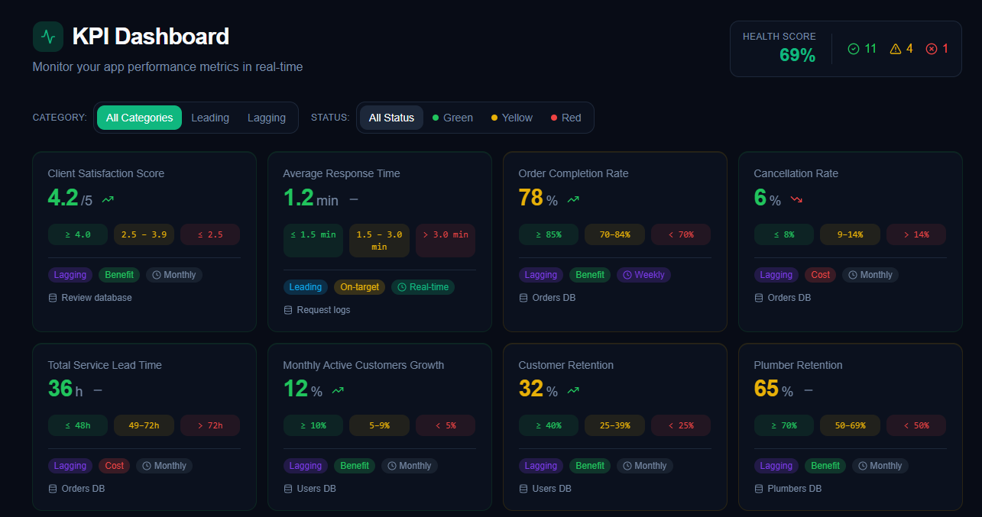
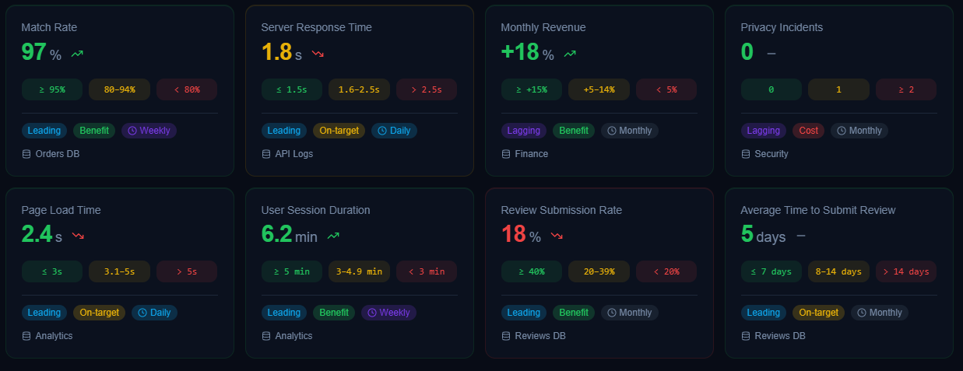
Fig.3 - Canaliza dashboard

Dashboard Description
The KPI Dashboard provides a real-time overview of the platform’s operational and business performance, combining leading and lagging indicators.
Each KPI displays its current value, trend, and status (green, yellow, or red), enabling quick interpretation. Metrics are organized by impact and measurement frequency to support clear and informed decisions.
A global Health Score summarizes overall system stability and business viability, allowing early risk detection and continuous performance improvement.

Revenue Model
- Transaction Commission 10% fee per completed service.

- VIP Subscription Monthly premium plan providing priority access to top-rated professionals and faster response times.

Project Timeline (21 Weeks)

Milestones | Weeks
M1 – Initial Planning and Modeling | Weeks 1-6
M2 – Architecture and initial prototype | Weeks 7-11
M3 – Backend and Core APIs Implementation | Weeks 12-16
M4 – Testing and Product Refinement | Weeks 17-19
M5 – Final Delivery and Presentation | Weeks 20-21

Project Governance

Project Governance
The project adopts a hybrid Agile–DevOps governance model, aligned with PMI/PMP principles, combining Agile SCRUM execution with formal project oversight. This model is implemented within a projectized organization, enabling shared authority between business, technical, and project management functions.
The DevOps Team is composed of multidisciplinary members, integrating development (Dev) and operations (Ops) expertise to streamline the Software Development Life Cycle (SDLC). This approach promotes close collaboration between business and technology stakeholders, supporting continuous integration, testing, deployment, and operational stability while breaking down traditional organizational silos.
From a governance perspective, strategic control, risk management, and stakeholder coordination remain under the responsibility of the Project Manager, while value definition, Agile process facilitation, and technical execution are handled by the Agile roles (Product Owner, Scrum Master, and Dev Team).
The Dev Team is intentionally structured with multiple complementary skill sets and overlapping competencies, ensuring redundancy and resilience, and mitigating risks related to knowledge concentration or resource unavailability.

Roles and Responsibilities

Product Owner (PO)
Gabriel Pestana

The Product Owner is responsible for defining the product vision, prioritizing the backlog, and ensuring alignment with business objectives.

Project Manager (PM)
Rui Monteiro

The Project Manager is responsible for overall project governance, including scope, schedule, cost, and risk management. This role coordinates stakeholders, monitors project progress, and ensures delivery in accordance with organizational and quality requirements.

Scrum Master (SM)
Dinis Xavier

The Scrum Master facilitates SCRUM practices and ceremonies, removes impediments, and supports team collaboration and continuous improvement to ensure effective Agile execution.

Dev Team – Cross-Functional Technical Team

Backend Software Engineer
Rui Monteiro

Responsible for implementing backend services, APIs, and data management, ensuring system performance, security, and reliability.

Frontend Software Engineer
Dinis Xavier

Responsible for developing user interfaces and integrating frontend components with backend services, ensuring usability and application performance.

DevOps Engineer
Daniel Pais

Responsible for CI/CD pipelines, deployment automation, and system monitoring, ensuring operational stability and reliable releases.

Quality Assurance (QA)
Rui Monteiro
Dinis Xavier
Daniel Pais

Quality assurance is a shared responsibility within the Dev Team. Team members define and execute testing activities, including functional, integration, and regression testing, validate non-functional requirements, and ensure that quality standards are met before each release.

Work Breakdown Structure

WBS
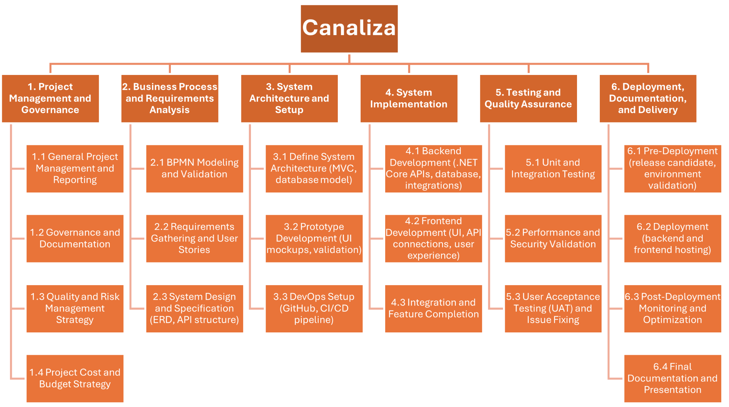

Fig.4 - Canaliza WBS

Gantt Chart
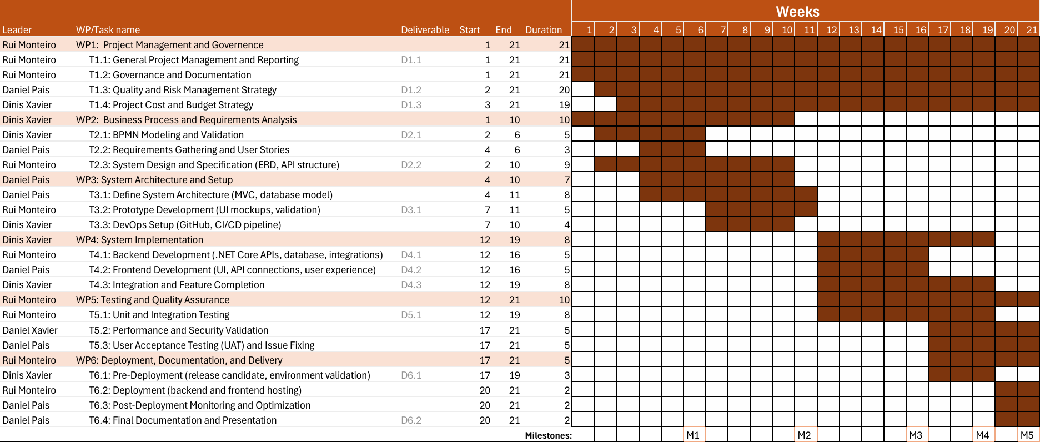
Fig.5 - Canaliza Gantt Chart

Description of Project deliverables
Deliverable Types
Report (R) | Prototype (P) | Piece of code or software module (S) | Workshop (W)

Dissemination Level
Public (PU) | Sensitive (SEN) | Confidential (CO)

Nº | Name/Description | WP | Leader | Type | Diss. Lev. | Date
1.1 | Project Plan & Schedule - A document outlining the project scope, sprint timeline, milestones, and overall execution strategy. | 1 | Dinis | R | SEN | M1
1.2 | Quality & Risk Register - A log containing defined quality criteria, identified risks, mitigation strategies, and monitoring procedures | 1 | Dinis | R | SEN | M1
1.3 | Cost & Budget Report - A detailed estimation of all project-related costs, including team salaries, infrastructure, tools, and licensing. | 1 | Dinis | R | SEN | M1
2.1 | Validated BPMN Diagram - An approved BPMN model representing the platform’s core processes and workflow interactions. | 2 | Dinis | R | SEN | M1
2.3 | System Design and Specification - A technical document including the ERD, API structure, software architecture, and module-level specifications. | 2 | Dinis | R | SEN | M1
3.1 | Interactive UI Prototype - A navigable prototype demonstrating the main user interface screens and validating key user flows. | 3 | Daniel | P | SEN | M2
4.1 | Core Backend APIs - A functional set of backend APIs implemented in .NET, integrated with the database and ready for frontend use. | 4 | Dinis | S | CO | M3
4.2 | Functional Frontend Interface - An operational frontend connected to the backend APIs, implementing essential UI components and workflows. | 4 | Dinis | S | CO | M3
4.3 | Integrated Application Build - A fully integrated system build where frontend and backend components operate together with completed features. | 4 | Dinis | S | CO | M3
5.1 | Test Execution Report - A report summarizing unit and integration test results, including detected issues and fixes performed. | 5 | Rui | S | CO | M4
6.1 | Release Candidate Validation Report - A validation document confirming that the release candidate meets all functional and technical requirements for deployment. | 6 | Rui | R | SEN | M5
6.2 | Final Technical Documentation & Demo Slides - Complete technical documentation of the system along with the final presentation and live demo materials. | 6 | Rui | R/W | SEN | M5

WBS Dictionary

WBS Responsibilities - In every one of the Work Packages, because the project is very small and our team is only composed of three people, all of us are assigned to each Work Package.

WP nº 1 - Project Management and government
Objective - This work package ensures the project is effectively planned, monitored, and controlled throughout its lifecycle. It covers planning, governance, quality assurance, risk management, and budget oversight to guarantee successful delivery of the MVP.

Resources:
- Reporting and Presentation Tools
- Documentation Tools
Task Number and Name | Description
1.1 General Project Management and Reporting | Define project objectives, create timelines, set milestones, and organize tasks into sprints to guide development and monitor progress.
1.2 Governance and Documentation | Establish decision-making processes, track project activities, maintain records, and ensure transparency for stakeholders.
1.3 Quality and Risk Management | Identify potential risks, define mitigation strategies, and implement quality assurance practices to maintain high standards throughout the project.
1.4 Project Cost and Budget | Plan, monitor, and control financial resources, ensuring expenses align with budget estimates and funding allocations.

WP nº 2 - Business Process and Requirement analysis

Objective - This work package focuses on understanding business needs, modeling core processes, and defining clear technical requirements. It ensures that the system design aligns with user expectations and supports efficient platform development.

Resources:
- Signavio
- Confluence
- Jira Product Discovery
- Confluence
- Visual Paradigm

Task Number and Name | Description
2.1 BPMN Modeling and Validation | Develop and validate BPMN diagrams to represent the platform’s main business workflows, ensuring process clarity and stakeholder alignment.
2.2 Requirements Gathering and User Stories | Collect and document user needs, translating them into detailed user stories and acceptance criteria for development planning.
2.3 System Design and Specification (ERD, API Structure) | Define the system’s architecture, including database schema (ERD) and API structure, to support scalable and consistent development.

WP nº 3 - System Architecture and Setup

Objective - This work package focuses on establishing the system’s technical foundation, including architecture design, prototype development, and DevOps configuration. It ensures the platform is structurally solid, visually validated, and ready for continuous integration and deployment.

Resources:
- Figma
- GitHub
- Cloud

Task Number and Name | Description
3.1 Define System Architecture (MVC, Database Model) | Design the overall system structure using the MVC pattern and define the database model to ensure scalability and maintainability.
3.2 Prototype Development (UI Mockups, Validation) | Create interactive UI mockups to visualize core user flows and validate design decisions with stakeholders before implementation.
3.3 DevOps Setup (GitHub, CI/CD Pipeline) | Configure version control and continuous integration/deployment tools to automate builds, testing, and delivery processes.

WP nº 4 - System Implementation

Objective - This work package covers the full development of the platform, including backend and frontend implementation, API integration, and completion of all core features. It ensures that the system is fully functional and ready for testing.

Resources:
- Visual Studio
- Microsoft Azure
- API’s
- DB Server

Task Number and Name | Description
4.1 Backend Development (.NET, Core APIs, Database Integrations) | Develop the server-side logic, APIs, and database integrations to support all core platform functionalities.
4.2 Frontend Development (UI, API Connections, User Experience) | Implement the user interface, connect it with backend services, and optimize user experience across devices.
4.3 Integration and Feature Completion | Integrate frontend and backend components, finalize all planned features, and ensure seamless functionality across the platform.

WP nº 5 - Testing and Quality Assurance

Objective - This work package ensures the platform meets quality standards, performs reliably, and fulfills user requirements. It includes testing, validation, and issue resolution to prepare the system for final delivery.

Resources:
- Visual Studio

Task Number and Name | Description
5.1 – Unit and Integration Testing | Conduct automated and manual tests on individual components and integrated modules to ensure correct functionality and data flow.
5.2 – Performance and Security Validation | Evaluate system performance under load and test for security vulnerabilities to guarantee reliability and data protection.
5.3 – User Acceptance Testing (UAT) and Issue Fixing | Involve end-users in testing the platform, collect feedback, and resolve identified issues to confirm the system meets business and user expectations.

WP nº 6 - Deployment Documentation and Delivery

Objective - This work package covers the final steps to release the platform to production, including environment validation, deployment, post-launch monitoring, and preparation of final documentation and presentations. It ensures the system is fully operational and delivered to stakeholders.

Resources:
- PowerPoint
- Azure

Task Number and Name | Description
6.1 – Pre-Deployment (Release Candidate Environment Validation) | Validate the release candidate in a staging environment to ensure stability and readiness for production deployment.
6.2 – Deployment (Backend and Frontend Hosting) | Deploy the backend and frontend components to the production environment, making the platform accessible to users.
6.3 – Post-Deployment Monitoring and Optimization | Monitor system performance, detect potential issues, and optimize for reliability, speed, and user experience.
6.4 – Final Documentation and Presentation | Prepare comprehensive technical documentation and conduct a final presentation/demo showcasing the platform’s features and project outcomes.

Budget & CashFlow

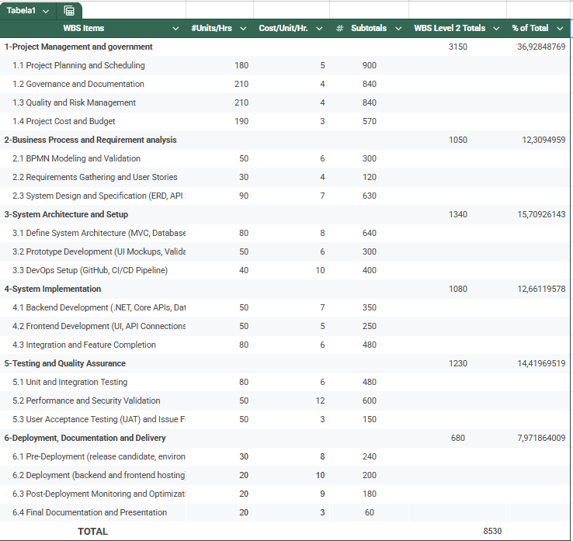
Project Cost Baseline

Fig.6 - Project Cost Baseline

Resource Cost Calculation
Fig.7 - Resource Cost Calculation

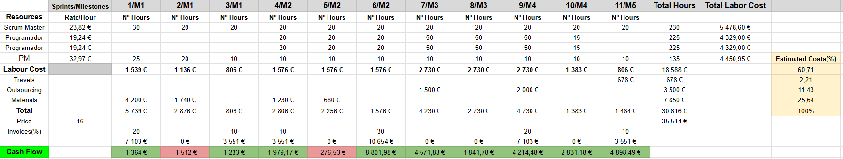
Cash-Flow
Fig.8 - Cash-Flow

Justification of Materials and Outsourcing Costs

Materials Costs
The materials budget accounts for all non-labor resources required to support the development, testing, and deployment of the platform. These costs are distributed across multiple milestones, reflecting the progressive needs of the project.
The initial higher investment in materials during early milestones is mainly associated with:
- Software licenses and development tools (e.g., IDEs, project management tools, API testing tools).
  - Atlassian – Jira
  - Postman – API testing and collaboration
  - Microsoft – Visual Studio, .NET tools, Azure DevOps
- Cloud infrastructure services, including virtual machines, databases, and storage required for development and staging environments.
  - Microsoft Azure – Virtual machines, databases, storage, monitoring
- Monitoring, security, and analytics tools, necessary to ensure system reliability and compliance.
  - Azure Application Insights
  - New Relic
  - Datadog
As the project advances, material costs decrease, since most tools and licenses are acquired upfront and reused across subsequent sprints. The total materials cost of €7,850 represents a realistic investment to guarantee a stable, secure, and scalable technical environment.

Outsourcing Costs
The outsourcing budget reflects the strategic use of external expertise for specialized tasks that are either not cost-effective or not feasible to perform in-house.
These costs are concentrated in specific milestones and correspond mainly to:
- External security and compliance reviews, including GDPR and data protection assessments.
  - Deloitte – Cyber Risk & GDPR Advisory
  - PwC – Data Protection and Privacy Services
- Cloud infrastructure configuration and optimization support, ensuring best practices in deployment and scalability.
  - Accenture – Cloud & DevOps consulting
  - Capgemini – Cloud architecture and deployment
- Specialized technical validation, such as performance testing or architecture review, conducted by external consultants.
  - Xebia – Software architecture and quality assurance
  - ThoughtWorks – Architecture review and technical validation
Outsourcing is intentionally limited to €3,500, ensuring cost control while mitigating technical and regulatory risks. This selective outsourcing approach allows the core team to remain focused on development while benefiting from expert validation at critical stages of the project.

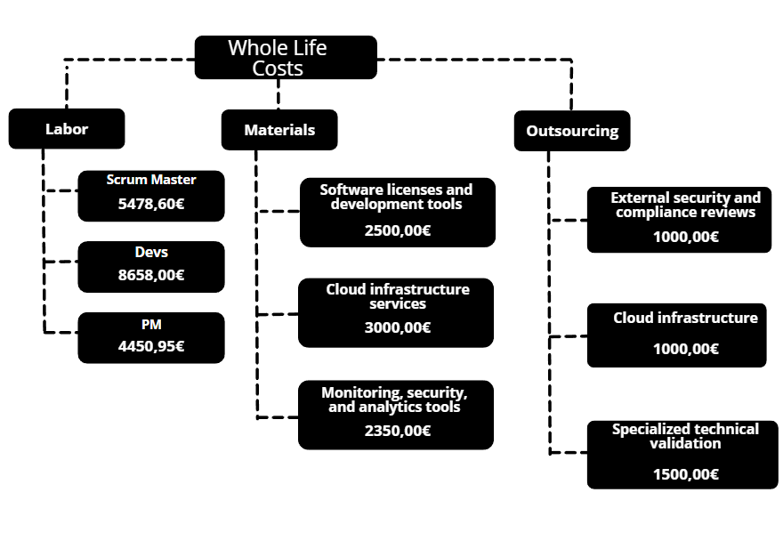
Cost Breakdown Structure (CBS)

Fig.9 - Canaliza CBS

Project Management Plan

Project Resource Management

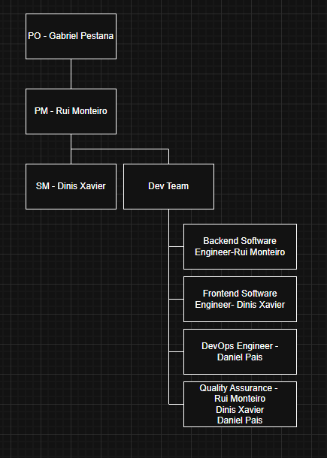
Organizational Breakdown Structure (OBS)
Fig.10 - Canaliza OBS

RACI Matrix
RACI Definition:

- Responsible (Does the work);
- Accountable (Approves/accountable for result);
- Consulted (Provides input/opinion);
- Informed (Receives notifications).

RACI Matrix – Project Governance & Deliverables

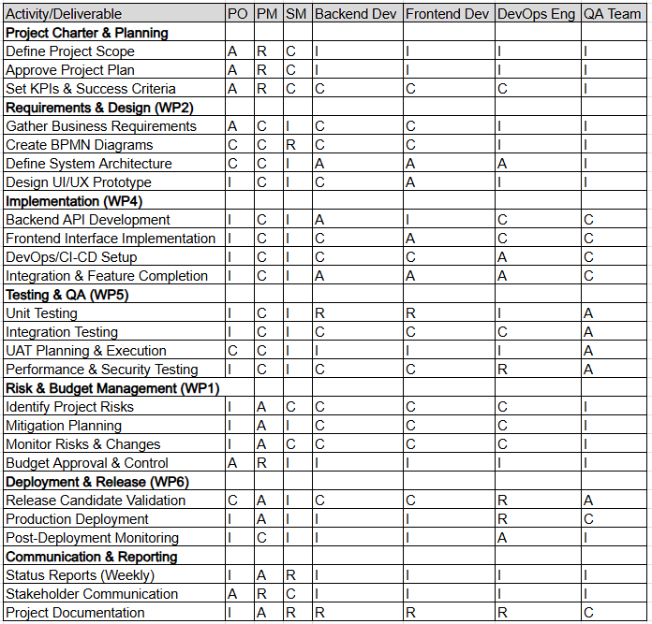

Project Risk Management

Risk Management Overview & Methodology
The Canaliza project employs a systematic, continuous risk management approach aligned with PMI standards. Risk identification, analysis, and monitoring activities occur throughout the 21-week project lifecycle to proactively address threats and capitalize on opportunities.

Risk Ownership & Responsibility:

- Risk Manager: Project Manager (Rui Monteiro);
- Risk Identification: All team members contribute during daily standups and retrospectives;
- Risk Monitoring: Weekly review by PM + PO + Steering Committee.

Risk Identification Technique
Technique Selected: Combined Approach (Brainstorming + Lessons Learned Interview).

The Canaliza team employed a hybrid identification methodology combining two techniques:

- Brainstorming Sessions (WP1 – Project Planning Phase):

- Participants: Entire project team (PM, SM, Backend Dev, Frontend Dev, DevOps);
- Methodology: Structured brainstorming identifying risks by Work Package and category;
- Rationale: Quick, cost-effective generation of diverse risk ideas from team expertise;
- Outcome: Initial 12-15 risk candidates identified in 2-hour workshop.

- Lessons Learned from Similar Projects (Experience-Based):

- Source: Team members' prior experience in e-commerce platform projects, API development, and DevOps deployments
- Rationale: Historical patterns inform realistic risk assessment; avoids "group-think" limitations of pure brainstorming
- Outcome: Refined risk list focused on plausible, project-specific threats

Risk Breakdown Structure (RBS)
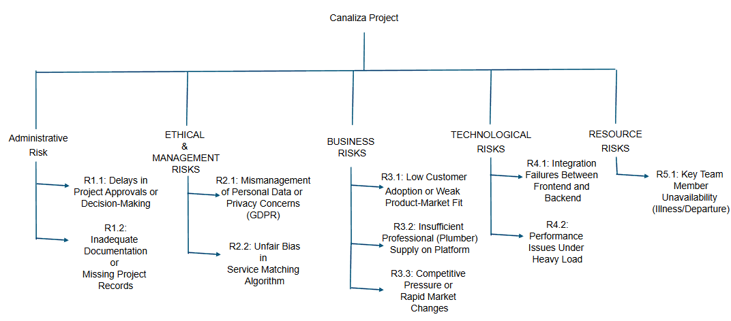
RBS Category Definitions:

- Administrative - Project governance, approvals, decision-making, documentation, communication;
- Ethical & Management - Data privacy, GDPR compliance, security, fair treatment, ethical algorithms;
- Business - Market adoption, customer demand, professional supply, revenue models, competition;
- Technological - Technical implementation, integration, performance, infrastructure;
- Resource - Team availability, skill gaps, knowledge concentration, burnout.

Risk Register – All Risks (Qualitative Analysis)

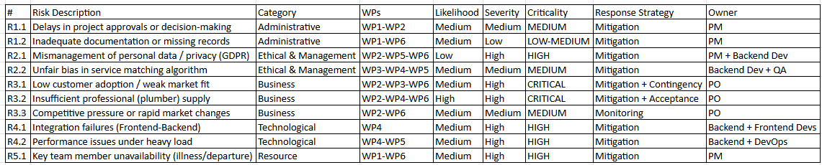

Response Plans for All Risks

ADMINISTRATIVE RISKS

Risk 1.1: Delays in Project Approvals or Decision-Making

Aspect | Details
Description of risk | Approval bottlenecks in governance may slow development, block critical path activities, and cause schedule delays
Proposed Risk-Mitigation Measures | Establish clear escalation: Technical blocker → SM → PM → PO (24-48 hr SLA)  Schedule governance meetings weekly on fixed days  Pre-approve common decisions  Asynchronous decision-making via shared docs.
Definition of the Risk Consequences | 1-3 day delay: minimal; 3-7 day delay: affects sprint tasks; >1 week: critical path impacted

Risk 1.2: Inadequate Documentation or Missing Project Records

Aspect | Details
Description of risk | Poor documentation leads to knowledge loss, rework, misunderstandings, and difficulty with project handover
Proposed Risk-Mitigation Measures | Documentation standards from Day 1  Assign documentation owners per module  Centralized repo (GitHub Wiki + Google Docs)  Definition of Done includes docs  Monthly doc audit  Handover checklist for final delivery
Definition of the Risk Consequences | Minor gaps: <2 hours rework; Major gaps: 5-10 hours; Severe gaps: new team unable to maintain code

ETHICAL & MANAGEMENT RISKS

Risk 2.1: Mismanagement of Personal Data or Privacy Concerns (GDPR)

Aspect | Details
Description of risk | Sensitive personal information exposed due to inadequate security, non-compliance with GDPR, or data breaches
Proposed Risk-Mitigation Measures | Data encryption at rest and in transit  GDPR compliance checklist  Security audits at Week 15 & 19  Data retention policy with auto-delete  Audit logging and monitoring  72-hour incident response plan
Definition of the Risk Consequences | Minor exposure (<10 users): <€1k fine; Medium breach (100+ users): €50k-500k fine; Severe: €1M+ fine + platform closure

Risk 2.2: Unfair Bias in Service Matching Algorithm

Aspect | Details
Description of risk | Matching algorithm unintentionally favors certain plumbers or discriminates against customers
Proposed Risk-Mitigation Measures | Transparent matching criteria (documented rules)  Fairness testing with diverse profiles  Quarterly algorithm audits  Guarantee new plumbers ≥20% match attempts  Anti-discrimination checks on protected attributes
Definition of the Risk Consequences | Minor bias: <5% complaints, correctable; Moderate: 5-15% complaints, 1-2 week redesign; Severe: >20% complaints, platform credibility at risk

BUSINESS RISKS

Risk 3.1: Low Customer Adoption or Weak Product-Market Fit

Aspect | Details
Description of risk | Low adoption of the Canaliza platform by customers may occur if the value proposition is not clear, the user experience is poor, or existing alternatives are perceived as sufficient, resulting in inadequate demand for plumbers and platform financial collapse.
Proposed Risk-Mitigation Measures | Validate market needs through property-manager interviews and usability testing with ≥15 users, targeting a System Usability Score ≥70/100. Deliver a focused MVP limited to core features (registration, service requests, matching, and reviews), while applying A/B testing to drive adoption with a target of ≥10% monthly growth.
Definition of the Risk Consequences | Low early adoption and engagement may lead to poor matching and high cancellations, resulting in insufficient revenue, professional churn, loss of investor confidence, and an unsustainable business model with negative ROI.

Risk 3.2: Insufficient Professional (Plumber) Supply

Aspect | Details
Description of risk | Insufficient number of qualified plumbers joining and remaining active on the platform causes long waiting times, low match rate, poor perceived reliability.
Proposed Risk-Mitigation Measures | Drive professional adoption through onboarding in under 2 hours, 0% commission for the first 50 plumbers during the first 30 days, reducing commission from 10% to 7%. Apply a geographically staged launch starting in Setúbal, expanding only after reaching ≥50 active plumbers.
Definition of the Risk Consequences | Low early professional recruitment may cause poor matching, high cancellations, slow response times, and customer churn, leading to low completion rates and an unreliable platform perception.

Risk 3.3: Competitive Pressure or Rapid Market Changes

Aspect | Details
Description of risk | Competitors launch digital platforms; market trends shift; regulatory changes affect market
Proposed Risk-Mitigation Measures | Weekly market monitoring; track competitors.  Speed to market: prioritize MVP by Week 20.  Flexible roadmap: ready to add adjacent services.  Strategic partnerships with plumbing associations.
Definition of the Risk Consequences | Minor threat: competitor in different geography; Moderate: competitor enters, reduces margins; Severe: well-funded competitor erodes market share

TECHNOLOGICAL RISKS

Risk 4.1: Integration Failures Between Frontend and Backend

Aspect | Details
Description of risk | Frontend and backend components fail to work together – API misalignment, data format incompatibilities, async/sync issues
Proposed Risk-Mitigation Measures | API contracts first (define specs before dev)  Automated integration tests on every commit  Weekly integration sync meetings  3-5 days buffer in sprint for troubleshooting  Gradual integration (1-2 features/week)
Definition of the Risk Consequences | Minor issue: 1-2 hours to fix; Moderate: 4-8 hours, staging found; Critical: >16 hours, blocks features; Cascade: multiple dependent features broken affects sprint tasks; >1 week: critical path impacted

Risk 4.2: Performance Issues Under Heavy Load

Aspect | Details
Description of risk | System becomes slow or unresponsive when concurrent user load increases; API response times exceed targets
Proposed Risk-Mitigation Measures | Load testing with 1000+ concurrent requests  Performance targets: API p95 ≤1.5s, page load ≤3s  Database indexing on high-query tables  Cloud auto-scaling enabled  Real-time monitoring with alerts
Definition of the Risk Consequences | Minor degradation: 1.5-2.0s response; Moderate: 2.0-3.0s, indexing needed; Severe: >3.0s or timeouts; Collapse: complete timeout, architecture rethink

RESOURCE RISKS

Risk 5.1: Key Team Member Unavailability (Illness/Departure)

Aspect | Details
Description of risk | Critical team member becomes ill, injured, or departs unexpectedly; single points of failure in knowledge
Proposed Risk-Mitigation Measures | Pair programming on critical modules for redundancy  Cross-training: weekly sessions on each other's domains  Comprehensive documentation enables quick onboarding  Clear backup assignment for each role  Modular development: clear separation of concerns
Definition of the Risk Consequences | 1-week absence: 1 sprint impact; 2 weeks: significant rework; Permanent departure: loss of 1/3 team, 2-4 week delay, €10k-20k contractor cost; Multiple departures: project viability at risk

26.6. Risk Monitoring & Control Plan

Monitoring Frequency & Activities:

Review Type | Frequency | Participants | Activities
Daily Standup | Every morning (15 min) | Dev Team + SM | Identify blockers; spot new risks
Sprint Planning | Every 2 weeks | Dev Team + PM + PO | Assess risks in upcoming sprint; allocate mitigation effort
Weekly Governance | Every Friday (1 hour) | PM + PO + Steering Committee | Risk register review; trend analysis; approve response actions
Monthly Risk Review | End of each month | PM + PO + Full Team | Comprehensive assessment; update probability/severity; close resolved risks
Retrospective | Every 2 weeks (sprint end) | Dev Team + SM | Lessons learned; identify patterns; prevent similar risks

Annex A: Prompt Engineering
Prompt Engineering.pdf

Annex B: Costs and Budget
GPI - Costs and Budget.xlsx

Annex C: Resource Cost
ResourceCost.xlsx

